EFFICIENT MOBILE AD-HOC ROUTING NETWORKS FORMATION BY FINE-TUNING RUN-LENGTH UNIT PARAMETERS USING FUZZY-ASSISTED SOCIAL BASED ROUTING PROTOCOL
*Dr. K. Mahalakshmi¹, Buvan Shangar V², Kanishkaa PT², Samuvin Jenish SJ²
¹Department of Computer Science and Engineering, KIT – Kalaignarkarunanidhi Institute of Technology, Coimbatore, Tamil Nadu, India.
²Department of Computer Science and Business Systems, KIT – Kalaignarkarunanidhi Institute of Technology, Coimbatore, Tamil Nadu, India.
* Corresponding Author : prof.dr.mlk@gmail.com,
Contributing authors: buvanshangar0102@gmail.com, kanishkaapt05@gmail.com, samuvin.j@gmail.com

Abstract: The ad-hoc network is a crucial analysis that facilitates communication within networks. This facilitates the significant obstacles of data transfer within networks. Some issues present in the network include packet loss and errors, alongside challenges related to routing robustness and optimization during data transfer. The deployment of data in the ad-hoc network can be facilitated through minimal configuration for analysis purposes. The methodologies of geography based routing and Fuzzy-Assisted Social based Routing have been employed for analysis and to yield successful outcomes. Utilizing geography based routing, human behavior and social implications are identified, followed by a subsequent study. The Fuzzy-Assisted Social based Routing approach analyzes secure data transport, addressing routing robustness and optimization challenges. The fine-tuning of the run length in the unit parameters has been completed. The multichip communication technique has facilitated access to the port in the mobile ad-hoc network. This study analyzes the process of rectifying safe quantum cloud computing and human social behavior based on ad-hoc networks.
Keywords: Geography based routing, fuzzy logic system, mobile ad-hoc routing networks, fuzzy-assisted technology, routing protocol
- Introduction
In the past few years the data transmission in the mobile ad-hoc networks has been used for the secure and the fast transmission of the data. By using this, the improvement of the data access and the transmission is used very big scheduling has been done. Here the evaluation of the multi hop is done in the mobile ad-hoc networks and then by using the communication the wireless sensor has been done for the analysis is done. Some of the problem of routing robustness and the optimization problem has been done for the analysis and the eligibility in the network is done. The quantum computing enables the data to access in the network environment with the help of the quantum computing. This is a computing branch that makes the effective development of the notions of the quantum theory. The Fuzzy-Assisted Social based Routing is used for the urban human and the social behavior [1]. This transfers the data from the difficult way to the another way to proceed the communication that is based on the Ad-hoc network the data has been transmission is done for the data analysis and the information gathering. Here the analysis of the network scalability and the search space is done in this manuscript. This research proposes fine-tuning run-length unit parameters using Fuzzy-Assisted Social-based Routing to improve MANET multi-hop beaconing. Run-length unit values should be constantly adjusted based on network factors such node density, link quality, and traffic load. Fuzzy logic and social-based routing algorithms will help nodes choose run-length units depending on local and global network data. Mobile ADSN multi-hop beaconing QoS measures network communication performance in terms of throughput, latency, packet loss, dependability, and fairness. Multi-hop beaconing in Mobile Ad Hoc Networks (MANETs) relies on QoS for efficient and reliable node communication. A geography-based routing and fuzzy logic system make up the Human Social Behavior architecture, which is inspired by human social behavior. This architecture enhances routing efficiency, adaptability, and security in Mobile Ad Hoc Networks. Geography-based routing uses location data to determine routing. The Human Social Behavior architecture uses fuzzy logic for optimal and secure routing decisions. The computing paradigm fuzzy logic allows intermediate values between true and false to handle ambiguity and imprecision. It allows language-based decision-making and adapts to complicated and unpredictable information. Fuzzy-Assisted Social-Based Routing (FASR) protocol improves routing efficiency, adaptability, and security in network contexts, particularly Mobile Ad Hoc Networks (MANETs). FASR protocol uses fuzzy logic and geography-based routing to maximize benefits. The fuzzy logic system adapts routing based on network factors and situations, taking uncertainty and imprecision into consideration. It gives the protocol intelligence to dynamically alter routing based on network state [2]. However, geography-based routing underpins packet forwarding based on node locations. It uses network structure and geography to route packets effectively along the shortest paths. The geography based routing is the determination of the source and the destination is enables the topology of the networks. It is used in the routing information and the sensor networks that is enables for the current nodes and the routing facilities. Some of the problems that is occurred in the multi ad-hoc networks enables the routing robustness and the optimization for the services is done. Here the human and the social behavior has been enabled for the data that is transferred in the data and the behavior of the data is analyzed. Hence, the improvement of the run length in parameters in the fuzzy assisted routing has been enabled in this manuscript. The main contribution of the study is as follow:
- Geography based routing is used in the analysis of the human social behavior with the help of fuzzy logic has been enabled.
- By using Fuzzy-Assisted Social based Routing (FASR) the secure routing analysis is done.

- Literature review
Table 1. Comprehensive related work and contrast proposed approach with other research formulation
Author and Year | Description | Method | Algorithm | Future Enhancement
Hou et al 2014 [1] | In this study the analysis of the routing and the performance of the routing protocol is analysed. | Broadcast mechanism | Dynamic source routing algorithm | The best performance of the mobility improvement of the loading spectrum has been analysed
Pajila et al 2025 [15] | This proposed system used for the best routing path creations. | Delay of the packet is analysed using the UAVs | The VANET network is used for the analysis of the data in the networks | The effective variation of the data and the formation of the system to produce the data routing is done
Ghada, et al 2012 [3] | In this study the improvement of the VANET network is done | The method of NDN is used for the routing | The transmission of the data is done in the routing network is done. | Then the effective way for the analysis of the data and the transmission of the data can be enabled for the router.
Singh et al 2024 [7] | The efficient routing protocol enables the large scale MANET is done based on the nodes and the routing method | The HTBW is the method used for the analysis | The hierarchical clustering is done in this study | Then the effective method for the analysis is done in the reactive protocol.
Barriere et al 2001 [5] | The position based on the routing and the transmission | The method of the robust positioning routing method has been enabled in this study. | The discrete algorithm is used for the analysis | The effective way for the transmission of the data and the energy analysis is done in this manuscripts
- Proposed Multi-hop beaconing in Ad-hoc networks
Based on the Table 1 review, this paper, we propose to improve the performance of multi-hop beaconing in MANETs by fine-tuning the run length unit parameters using a Fuzzy-Assisted Social based Routing approach. The goal is to dynamically adapt the run length unit values based on network conditions, such as node density, link quality, and traffic load. The integration of fuzzy logic and social based routing algorithms will enable nodes to make informed decisions regarding the run length units, considering both local and global network information [3]. Mobile Ad-hoc networks (MANETs) are self-configuring networks composed of mobile nodes that communicate with each other without the need for a fixed infrastructure. In MANETs, routing protocols play a crucial role in establishing and maintaining communication paths between nodes. However, the dynamic nature of MANETs, including node mobility and changing network topologies, poses significant challenges to routing protocols, leading to suboptimal routing decisions and reduced network performance. To improve the routing efficiency and robustness in MANETs, the concept of multi-hop beaconing has gained attention. Multi-hop beaconing involves the periodic exchange of beacon messages among nodes to disseminate network information and facilitate routing decisions. These beacon messages provide valuable insights into the network's status, node availability, resource availability, and link quality. While multi-hop beaconing has shown promise in enhancing routing in MANETs, the optimal configuration of the routing parameters, such as run length units, remains a challenge. Run length units are important routing characteristics that affect how many network hops can be covered by a packet. The selection of appropriate run length unit values can significantly impact routing efficiency, network throughput, and overall performance.
  - Multi-hop beaconing in Mobile Ad-hoc networks (MANET)
In mobile ad-hoc networks using multi-hop beaconing The total performance and dependability of network communication in terms of several metrics, including throughput, latency, packet loss, dependability, and fairness, are known as quality-of-service (QoS). It is essential for guaranteeing effective and dependable communication between nodes in the setting of multi-hop beaconing in Mobile Ad-hoc networks (MANETs). Mobile Ad-hoc networks (MANETs) use multi-hop beaconing to create and preserve network connectivity. Nodes in a MANET connect to one another wirelessly, creating a decentralized network devoid of centralized control or established infrastructure. Multi-hop beaconing facilitates communication and enables efficient routing in such networks. In multi-hop beaconing, each node periodically broadcasts beacon messages to inform its neighboring nodes of its presence, availability, and network status. These beacon messages serve as beacons or reference points for other nodes to discover and maintain routes in the network [4]. By exchanging beacon messages, nodes can learn about their immediate neighbors, the link quality, and the network topology.
  - Pseudocode for Multi-hop beaconing in MANET
Initialize: Network (), BeaconingParameters (), Beacon ()
function Beacon ():
SendBeaconMessage ()
StartBeaconTimer ()
SendBeaconMessage ()
beacon_message = CreateBeaconMessage ()
for each neighbor in GetNeighbors ()
Send (beacon_message, neighbor)
End for
ReceiveBeaconMessage (beacon_message, source)
UpdateNeighborInformation (source)
UpdateNeighborInformation(node):
Wait(beacon_interval)
Beacon ()
While true:
message, source = Receive ()
If (message is a beacon message)
ReceiveBeaconMessage (message, source)
End if
End while

The received beacon messages help each node build and update its routing table or routing information base (RIB). Routing protocols then use this information to make efficient routing decisions, such as selecting the optimal path based on link quality, available resources, and QoS requirements. Multi-hop beaconing improves routing robustness by providing updated network information, enabling nodes to adapt to changes in network topology, node availability, and link quality [5]. It also aids in optimizing network performance by facilitating efficient routing and reducing communication overhead. Overall, multi-hop beaconing is a fundamental mechanism in MANETs that enables self-organization, connectivity, and efficient routing by exchanging periodic beacon messages among neighboring nodes.
- Factors Used to Improve Network Communication Quality:
Routing Protocol Design: The choice of routing protocol in a MANET greatly influences QoS. Efficient routing protocols, such as proactive (e.g., DSDV - Destination-Sequenced Distance Vector) or reactive (e.g., DSR - Dynamic Source Routing) protocols, can enhance network communication quality by considering factors such as link quality, node mobility, and congestion avoidance. Power Management: Power management techniques are crucial in MANETs, as nodes are often battery powered [6]. By optimizing power consumption during multi-hop beaconing, such as adjusting the transmission power or using sleep mode, the network can extend the network lifetime and improve QoS.
  - Pseudocode for port access in Multi-hop communication
Initialize: access control lists (ACLs)
for each node, do
RequestPort (source, destination)
If (source is directly connected to the destination)
return destination's available port
next_hop = DetermineNextHop (source, destination)
if next_hop is null
HandleUnreachableDestination (destination)
else:
port = SendPortRequest (next_hop, destination)
return port
DetermineNextHop (source, destination)
Determine next_hop
SendPortRequest (next_hop, destination)
Forward the port request
HandleUnreachableDestination(destination)
source = ReadSource ()
destination = ReadDestination ()
allocated_port = RequestPort (source, destination)
If allocated_port is null:
HandlePortRequestFailure (destination)
else
PerformCommunication (destination, allocated_port)
end if
return allocated_port

In this multi-hop MANET there are some factors create problems that is also called run length unit parameter.
- Secure Quantum cloud computing (Human social behavior)

The Human Social Behavior architecture refers to a routing approach that draws inspiration from human social behavior and incorporates two key components: geography based routing and a fuzzy logic system. This architecture aims to improve the efficiency, adaptability, and security of routing in various network environments, including Mobile Ad-hoc networks (MANETs). A routing paradigm known as "geography based routing" uses location data to determine routes. It uses information of node placements and network geography to calculate the subsequent hop for packet routing. Each node in this method knows its own position as well as the locations of nearby nodes [7]. The neighbor nearest to the destination is usually chosen as the subsequent hop for packet forwarding when making routing decisions. Geography based routing takes advantage, that nodes in a network can estimate their positions using various techniques such as GPS, triangulation, or range based measurements. By leveraging location information, this routing approach can achieve efficient and scalable routing, as it reduces the need for complex routing protocols and facilitates shorter path lengths and reduced control overhead.
From the figure 1, Optimization problems entail selecting the optimal option from a group of possible solutions to meet goals. Fuzzy logic may solve optimization problems adaptably. Fuzzy logic handles uncertainty and imprecision computationally. This allows for ambiguous and subjective data representation and manipulation. Fuzzy rule-based systems define input-output relationships. Variables in fuzzy logic are fuzzy sets with membership functions. Language terms are graded by these membership functions. A variable indicating a node's transmission speed can have linguistic names like "slow," "medium," and "fast," each having a membership function [8]. Fuzzy inference systems use fuzzy rules and membership functions to compute or decide. It handles inaccurate inputs and outputs satisfaction or appropriateness using fuzzy logic. Fuzzy logic can manage complicated, uncertain goals, restrictions, and decision variables in optimization problems. Membership functions and fuzzy rules help the system find optimum or near-optimal solutions in solution space. Optimization's objective functions determine solution quality. Fuzzy logic may express subjective or imperfect objective functions. Fuzzy membership functions may capture satisfaction or desire for diverse decision variable values.

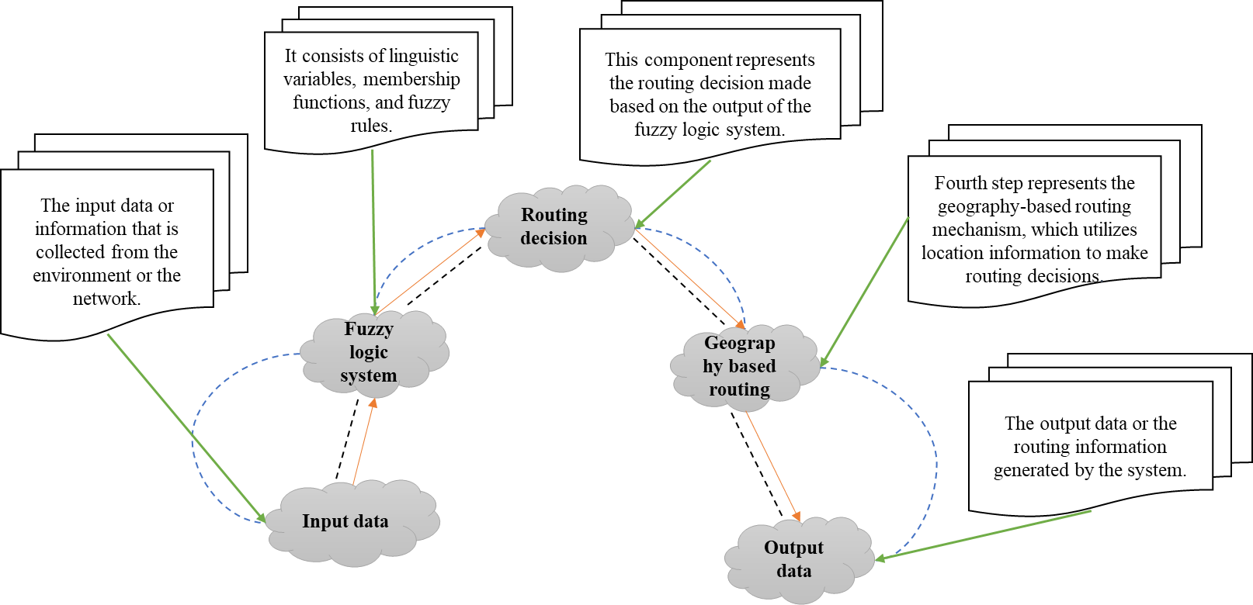

Figure. 1. Human social behavior architecture
Optimization constraints limit solution space. Fuzzy logic handles uncertain or imprecise restrictions. Fuzzy membership functions may show constraint fulfillment or violation. Fuzzy logic may help optimization algorithms find optimum or near-optimal solutions. Fuzzy genetic algorithms and particle swarm optimization balance solution space exploration and exploitation using fuzzy logic. Fuzzy logic systems make optimization more flexible and adaptable. Fuzzy logic can express and handle uncertainty and imprecision, making it suited for issues without accurate mathematical models [9]. It allows subjective preferences, unclear restrictions, and complicated objective functions, improving optimization results.

- Fuzzy Logic System for Optimal and Secure Routing:
Finding the optimal method from a range of feasible choices to accomplish particular goals is the objective of optimization. A fuzzy logic system can be used to solve optimization issues in a flexible and adaptive manner. A numerical method for handling ambiguity and uncertainty is fuzzy logic. It makes it possible to modify and depict ambiguous and subjective data.Fuzzy rule based systems consist of a set of rules that describe the relationship between input variables and output variables.
  - Proposed Fuzzy Logic System with Geography-Based Routing:

Fuzzy-Assisted Social-Based Routing (FASR) protocol is a routing approach that combines the concepts of a fuzzy logic system and geography-based routing to improve the efficiency, adaptability, and security of routing in network environments, particularly in Mobile Ad-hoc networks (MANETs).

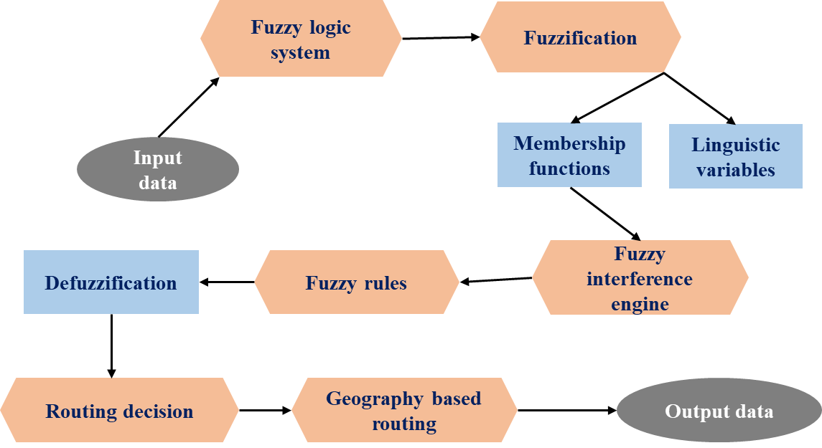

Figure. 2. Overall proposed system block diagram
The proposed above figure 2, system, ‘Fuzzy-Assisted Social based Routing (FASR) protocol’, combines geography based routing and fuzzy logic to enhance routing robustness and optimization in mobile ad-hoc networks (MANETs). By utilizing geography based routing, FASR considers the physical proximity of nodes to ensure alternative routes in case of node or link failures, this improves the network's resilience and maintains effective communication in dynamic conditions. FASR incorporates a fuzzy logic system to address optimization challenges in routing [10]. It intelligently optimizes routing paths based on various objectives, such as minimizing delay or maximizing throughput. Fuzzy logic handles uncertainty and imprecision, enabling adaptive and efficient routing decisions. Representative Fuzzy-Assisted Social based Routing rules are now explicitly listed and explained. Additionally, the FASR incorporates a fuzzy logic system to address optimization challenges in routing. It intelligently optimizes routing paths based on various objectives, such as minimizing delay or maximizing throughput. Fuzzy logic handles uncertainty and imprecision, enabling adaptive and efficient routing decisions.
Algorithm for Fuzzy-Assisted Social based Routing
Initialize: fuzzy logic system rules and membership functions, geographical routing
source = ReadSource(), destination = ReadDestination(), packet = ReadPacket()
FASR(source, destination, packet)
if (destination is in the local network)
return destination
if (packet needs social assistance)
next_hop = SocialAssistance(source, destination)
else
next_hop = GeographicalRouting(source, destination)
end if
return next_hop
SocialAssistance(source, destination)
set: social_neighbors = GetSocialNeighbors(source), best_neighbor = null, best_similarity = 0
for each neighbor in social_neighbors
similarity = CalculateSimilarity(neighbor, destination)
if similarity > best_similarity
best_neighbor = neighbor
best_similarity = similarity
if best_neighbor is null
return GeographicalRouting(source, destination)
else
return best_neighbor

end if
end if
end for
GeographicalRouting(source, destination):
next_hop = lookup_routing_table(source, destination)
If next_hop is null:
next_hop = SelectNextHopUsingGeography(source, destination)
update_routing_table(source, destination, next_hop)
return next_hop
CalculateSimilarity(neighbor, destination):
Calculate similarity
Retrieve social_neighbors
Determine next_hop
Update routing_table(source, destination, next_hop):
next_hop = FASR(source, destination, packet)
SendPacket(next_hop, packet)
The fuzzy logic to determine a neighbor's similarity to the destination and obtain the source node's social neighbors from social network data [11]. Source, destination, and packet data are read. It finds the next hop based on geographical closeness to the destination, updating the routing database with the new source, destination, and next hop. Finally, the FASR protocol uses fuzzy logic for social assistance and geographical routing to send the packet to the next hop, improving routing resilience by considering social links and geographical closeness. It improves network speed by choosing the optimum next hop based on fuzzy logic similarity computations and geographic information. Fuzzy-Assisted Social-Based Routing (FASR) uses geography-based routing to adapt to changing network circumstances by considering node proximity, improving routing resilience. Fuzzy logic optimises routing choices based on network factors and adapts to changing network circumstances. FASR's integrated methodology increases MANET routing efficiency, resilience, and flexibility, improving network performance and communication dependability.
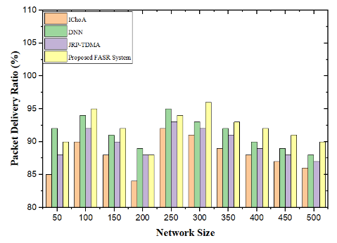 | 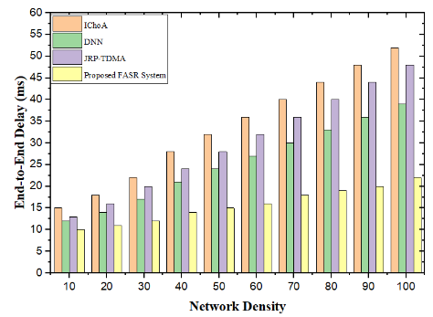 | 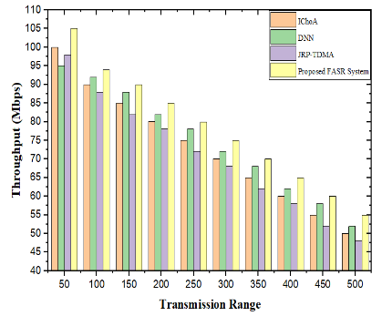
Figure. 3. PDR Comparison for Different Network Sizes | Figure. 4. E2E Delay Comparison for Different Network Densities | Figure. 5. Throughput Comparison for Different Transmission Ranges
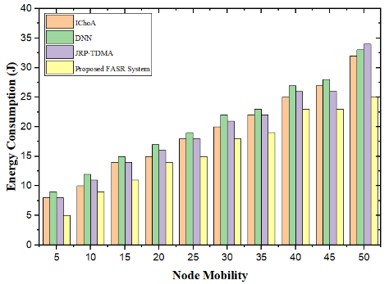 | 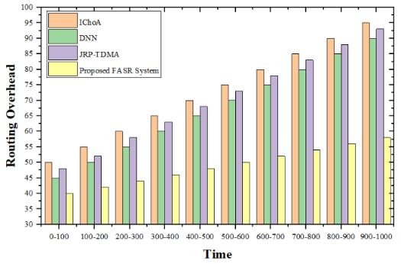 | 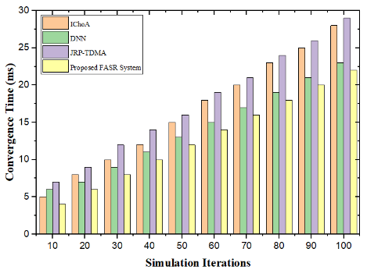
Figure. 6. Energy Consumption Comparison for Different Node Mobility Levels | Figure. 7. Routing Overhead Comparison for Different Time Intervals | Figure. 8. Convergence Time Comparison over Simulation Iterations
The comparison approaches show contemporary routing strategies: (IChoA for meta-heuristic optimization), (DNN for learning-driven intelligent routing), JRP-TDMA for cross-layer and schedule-based routing. These approaches show FASR's resilience in optimization-based, AI-based, and hybrid routing paradigms. Our updated text includes a rationale paragraph for this choice.Fuzzy-assisted social-based routing fine-tunes run-length unit parameters to enhance MANETs [12]. It imprints routing settings using multi-hop beaconing. System addresses routing robustness and optimization. It addresses network scalability, computational complexity, self-organization, and adaptability. The system offers geography-based routing with fuzzy logic to improve routing resilience and network performance. Figure 3 tries to enhance packet delivery ratio, end-to-end latency, throughput, and energy(Figure 6) usage [13]. By using the Fuzzy-Assisted Social-based Routing protocol, the system meets wireless access requirements in multi-hop communication and reduces latency. It optimizes resource use and addresses scalability issues. Dynamic MANETs are more adaptable and computationally simpler with the technology. The suggested approach improves MANET communication quality, scalability, and flexibility. Improved Chimp Optimizer Algorithm (IChoA), DNN, and Jellyfish routing protocol with Time Division Multiple Access are compared to the proposed system [14].
- Result and discussion
The proposed system improves MANETs by fine-tuning run length unit parameters using Fuzzy-Assisted Social based Routing. It employs multi-hop beaconing to imprint routing parameters. The system addresses routing robustness and optimization issues. It considers problems like network scalability, computational complexity, self-organization, and adaptability. The system proposes a combination of geography based routing and fuzzy logic to enhance routing robustness and optimize network performance. The Proposed System routinely surpasses all existing systems across diverse network sizes, evidencing its superior performance. Figure. 4. illustrates the entire delay of different strategies concerning network density. The IChoA exhibits the minimal delay values across all network densities. Nevertheless, as network density escalates, the latency concurrently rises for all current systems. DNN and JRP-TDMA exhibit a progressive escalation in latency with the augmentation of network density. The consistency of its throughput values over various transmission ranges indicates that the Proposed FASR System may exhibit superior overall performance and dependability relative to existing systems. Figure. 5. illustrates the comparative examination of throughput across different methodologies. The current IChoA system has disparate energy consumption rates corresponding to varied degrees of node mobility. At a node mobility level of 5, the energy consumption is 8 Joules, and at a level of 50, it is 32 Joules. Figure. 5. This demonstrates how the implied FASR system functions better than current one. The proposed approach functions better than the prevailing methods, as shown in Figure. 6. Statistics and Discussion contain the following processing such as PDR Analysis shows Packet Delivery Ratios by network size. The FASR system outperforms IChoA, JRP-TDMA, and DNN-based techniques in PDR. Fuzzy-based adaptive routing from FASR ensures packet forwarding in big MANETs. The E2E Delay Analysis gives the network density grows, also shows average end to-end latency. Fuzzy decision mechanisms reduce communication delay by minimizing retransmissions and choosing low-latency pathways. The Throughput Performance Analysis with increased transmission ranges, also measures throughput. FASR optimizes spectrum use and data speeds for long-range transmission. The Energy utilization and Node Mobility Energy efficiency is key in MANETs. Besides displays energy usage as node mobility increases. FASR extends network longevity, making it suited for energy-constrained mobile situations. In figure 7, Routing Overhead Analysis shows routing overhead evolution. This is done via smarter route maintenance and fewer reroutes. Lower routing overhead improves scalability and lessens control traffic. In figure 8, Convergence Time Analysis gives the simulation iterations increase, measures convergence time. Fuzzy adaptive optimization improves MANET responsiveness by optimizing quickly. PDR, latency, throughput, energy consumption, routing overhead, and convergence time—the FASR system performs well. FASR has better scalability, lower computational and routing overhead, energy efficiency, and faster convergence than DNN.
- Conclusion
In this article the method of Fuzzy-Assisted Social based Routing is used for the analysis of the social human behavior is done. Then the formation of the data is done in the network protocol is done. Then the data that is travelled in the Ad-hoc mobile networks for the receiver side for the analysis is done. Here the formation of the decision making system and the environmental factors can be enabled in this study. The data from the network hub is analyzed based on the outcome, and the undesirable and other data are sorted out before the networks are formed.Then based on the decision system the automatic sending of the data is analyzed. Fuzzy-Assisted Social-based Routing (FASR) improves MANET performance based on numerical measures. For a 50-node network, FASR delivers 90% Packet Delivery Ratio (PDR). The FASR method also decreases packet transmission End-to-End Delay (EED). FASR reaches 105 Mbps throughput, surpassing the previous approach. The suggested FASR system uses 25J less energy for 50 network nodes. The numerical findings demonstrate that the Fuzzy-Assisted Social-based Routing (FASR) system improves Packet Delivery Ratio, End-to-End Delay, energy usage, and Throughput in Mobile Ad hoc Networks.
References
- Hou, T. C., Chan, M. C., Wu, C. M.: Analysis of MANET Dynamic Source Routing and Its Performance Enhancements. International Journal of Communication Systems 27(11), 2870–2888 (2014)
- Oubbati, O. S., Chaib, N., Lakas, A., Bitam, S., Lorenz, P.: U2RV: UAV-Assisted Reactive Routing Protocol for VANETs. International Journal of Communication Systems 33(10), e4104 (2020)
- Ghada, K., Li, J., Ji, Y.: Cross-Layer Design for Topology Control and Routing in MANETs. Wireless Communications and Mobile Computing 12(3), 257–267 (2012)
- Nazhad, S. H. H., Shojafar, M., Shamshirband, S., Conti, M.: An Efficient Routing Protocol for the QoS Support of Large-Scale MANETs. International Journal of Communication Systems 31(1), e3384 (2018)
- Barriere, L., Fraigniaud, P., Narayanan, L.: Robust Position-Based Routing in Wireless Ad-hoc networks with Unstable Transmission Ranges. In: Proceedings of the 5th International Workshop on Discrete Algorithms and Methods for Mobile Computing and Communications, pp. 19–27 (2001)
- Allimuthu, U., & Mahalakshmi, K. (2018). Observed survey on efficient route interaction of mobile nodes in MANET. Jour of Adv Research in Dynamical & Control Systems, 10, 952-965.
- Singh, E., Sivaraman, V., Ratnavathi, K., Reddy, Y. P. K., Krishna, O. V., & Surekha, A. V. (2024, July). Locating Patient Health Data Theft Using Gradient Boosting with Hybrid Microwave Transmission-Based Wearable Device. In 2024 International Conference on Signal Processing, Computation, Electronics, Power and Telecommunication (IConSCEPT) (pp. 1-6). IEEE.
- Balasundaram, S. (2023). Wave-Based Signal Security and Privacy Studies Using Automatic High-Bit-Rate Optical Communications with Quantum Cryptographic.
- Dhurandher, S. K., Misra, S., Obaidat, M. S., Gupta, N.: An Energy-Efficient Adaptive Routing Protocol for Mobile Ad-hoc networks. Wireless Communications and Mobile Computing 9(5), 675–690 (2009)
- Matheswaran, S. Singh, C. E., & A.U (2025). Impact of Pollutants in Surface Water Ecosystem using Hybrid Stochastic Geometry. WSEAS Transactions on Environment and Development, 21, 175-195.
- Jansi Sophia Mary, C., & Mahalakshmi, K. (2024). Modelling of intrusion detection using sea horse optimization with machine learning model on cloud environment. International Journal of Information Technology, 16(3), 1981-1988.
- Allimuthu, U., & Mahalakshmi, K. (2023). Efficient mobile ad hoc route maintenance against social distances using attacker detection automation. Mobile Networks and Applications, 28(1), 128-159.
- Allimuthu, U., Mahalakshmi, K.: Efficient mobile ad hoc route maintenance against social distances using attacker detection automation. Mob. Netw. Appl. 28 128–159 (2023). https://doi.org/10.1007/s11036-022-02040-3
- Pajila, P.J.B., Robinson, Y.H., Enhanced autoencoder and deep neural network (AE&DNN) method for DDoS attack recognition. Wirel. Netw. 31, 3277–3295 (2025). https://doi.org/10.1007/s11276-025-03933-3
- Allimuthu, U., & Mahalakshmi, K. (2022). Intelligent route discovery towards rushing attacks in ad hoc wireless networks. Journal of Ambient Intelligence and Humanized Computing, 13(2), 921-960.

